





 | 
 |  |  |  |  |  | 125 | 1,56,062.50
 | 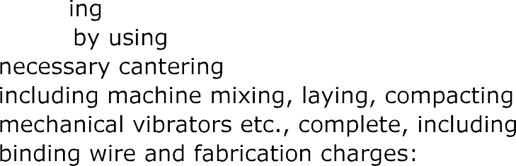
 |  |  |  |  |  | 800.00 | 20,440.00
 |  |  |  |  |  | 80.00 | 2,26,400.00
 | 
 |  |  |  |  |  | 100.00 | 1,29,000.00






 | 


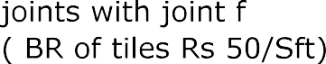
 |  |  |  | 120 | 2,18,400.00
 | 
 | 
 |  |  |  | 30.00 | 22,,560..00
Total |  |  |  |  |  | 1098282.500





