
N R BUILDERS & DEVELOPERS
Mobile: 9926428226 | Email: roopeshsalian@yahoo.co.in
Sai Dwaraka, Dandekeri Road, Yeyyadi, Konchady Post, Mangalore 575008
GSTN: 29AJKPR3906M2Z1

Date: 12.10.2025







 | 
 | Earth work excavation by manual in ordinary soil upto 1.50m and stacking the excavated materials safely from the edge of excavation and spreading soils with in the plot |  |  | 60 00 | 70,800
 |  |  |  | 25.00 | 63,800.00
 | Providing and laying PCC 1.4.8 using (40mm graded aggregate) under foundation of walls, column footings, including curing etc complete
 | 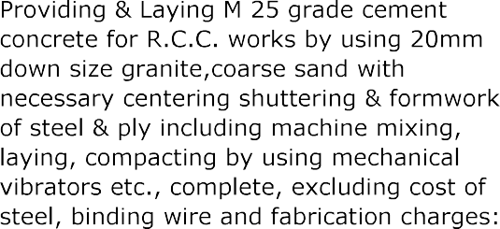
 | 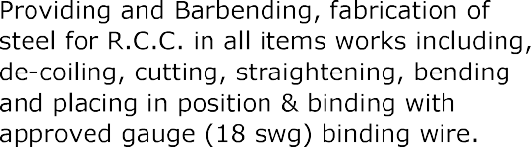
 | 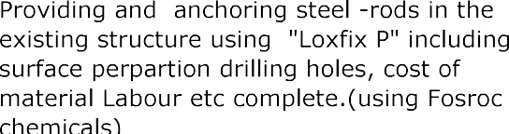

 | 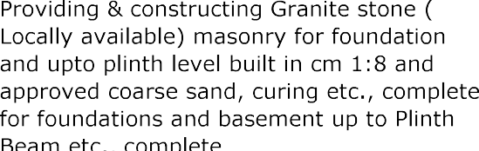
 | 
 | 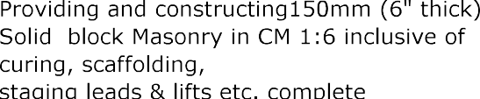
 |  |  |  |  | 60 00 | 1,23,900.00
 | Providing internal wall plastering in CM 1.4, 12mm thick on walls and adjacent concrete surfaces including trowel finish scaffolding curing etc complete
 | Providing and making internal wall plastering patch work (for existing walls) in CM1.4 including Trowel finish scaffolding curing etc complete |  | 143.00 | Sft | 40.00 | 5,720.00
 | 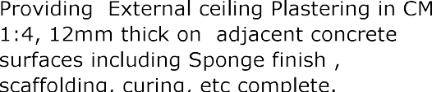
 | 
 | 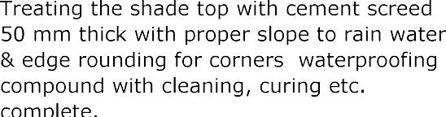
 | 
 | 
 | 
 | Providing and laying Cement concrete bed for flooring (sub base), 100mm thick (4i nch) in PCC 1.4.8 using (40mm graded aggregate) |  |  |  | 85.00 | 1,07,100.00

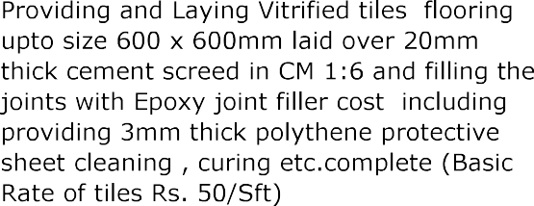
Providing and Laying Vitrified tiles skirting upto size 600x600mm laid over 20mm thick cement screed in CM 1.6 and filling the joints with Epoxy joint filler with 3mm spacer, cost including cleaning, curing etc. complete (Basic Rate of tiles Rs 50/-Sft)

Providing and Laying 20mm thick granite flooring laid over cement screed 1.6, 20mm thick, joints shall be filled using epoxy joint filler including wastages and transport etc complete ((Basic Rate Rs 150/-Sft)

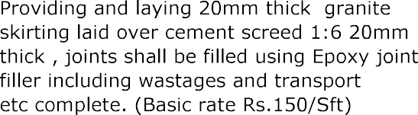

12,27,240.00

